**SMART PUBLIC RESTROOM**

Here the simulation and the output simple basic circuit with the pir and ultra sonic sensors in the simulation.

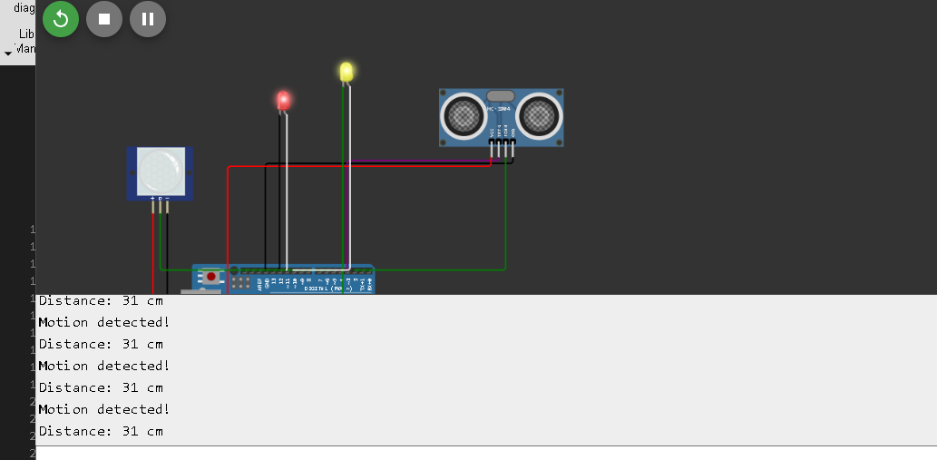This picture denotes the simulation that occurs in the pir and ultra sonic sensor the pir sensor detects the motion and the ultra sonic sensor detects the distance .the pir sensor detects the motion the light gets turn on. if the motion does not detected it gets turned off. The minimum distance that set is detected and the distance is below or above the value the light gets turned on . if it doesn’t attain the required distance it gets turned off. The below picture show the no motion detected and the distance is set to above level.

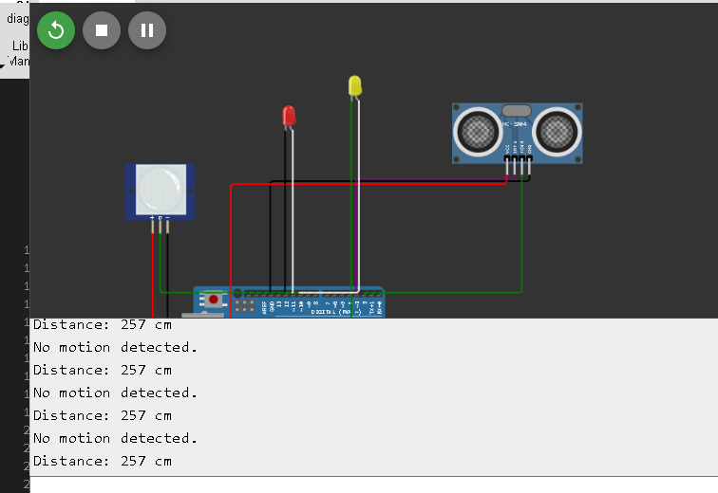

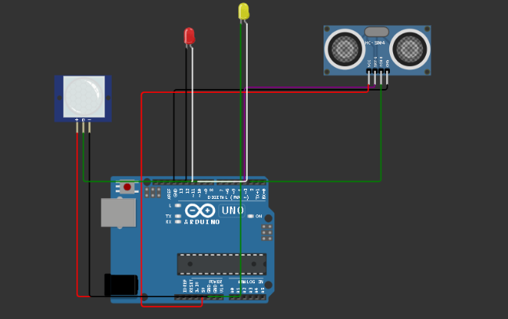

This is the basic circuit of the sensor and Arduino board pir senor ground positive and negative terminals are connected out center and vcc are connected to board, then the ultrasonic sensor is connected vcc, trigger, echo, ground terminals are connected to the board. The Arduino board got power supply and the led are connected to ultra-sonic and pir to detect the motion and distance.

Coding for this simulation in python

import RPi.GPIO as GPIO

import time

# Pin Definitions

pir_pin = 5 # PIR sensor pin

trig_pin = 3 # Ultrasonic sensor Trig pin

echo_pin = 2 # Ultrasonic sensor Echo pin

pir_led = 11 # LED for PIR sensor

ultrasonic_led = 10 # LED for Ultrasonic sensor

# Setup GPIO

GPIO.setmode(GPIO.BOARD)

GPIO.setup(pir_pin, GPIO.IN)

GPIO.setup(trig_pin, GPIO.OUT)

GPIO.setup(echo_pin, GPIO.IN)

GPIO.setup(pir_led, GPIO.OUT)

GPIO.setup(ultrasonic_led, GPIO.OUT)

def read_pir():

pir_value = GPIO.input(pir_pin)

GPIO.output(pir_led, pir_value) # Turn PIR LED on if motion is detected

if pir_value == GPIO.HIGH:

print("Motion detected!")

else:

print("No motion detected.")

def read_ultrasonic():

GPIO.output(trig_pin, GPIO.LOW)

time.sleep(0.2)

GPIO.output(trig_pin, GPIO.HIGH)

time.sleep(0.00001)

GPIO.output(trig_pin, GPIO.LOW)

pulse_start = time.time()

while GPIO.input(echo_pin) == GPIO.LOW:

pulse_start = time.time()

pulse_end = time.time()

while GPIO.input(echo_pin) == GPIO.HIGH:

pulse_end = time.time()

pulse_duration = pulse_end - pulse_start

distance = pulse_duration * 17150 # Speed of sound is 34300 cm/s

distance = round(distance, 2)

GPIO.output(ultrasonic_led, distance < 50) # Turn Ultrasonic LED on if distance < 50cm

print(f"Distance: {distance} cm")

# Main loop

try:

while True:

read_pir()

read_ultrasonic()

time.sleep(1) # Delay for readability, adjust as needed

except KeyboardInterrupt:

GPIO.cleanup()

According to pin numbers in the program the sensors are connected and executed and simulated.

# *Coding for cleanliness and occupancy sensor for real time data analysis*

import requests

import time

# Function to read sensor data (replace with actual sensor readings)

def read_sensors():

occupancy = 1 # Example occupancy value (1 means occupied, 0 means empty)

cleanliness = 0.8 # Example cleanliness value (0.8 means 80% clean)

return occupancy, cleanliness

# Function to send data to the platform

def send_data(occupancy, cleanliness):

url = "http://your_platform_endpoint.com/api/update_data" # Replace with actual API endpoint

payload = {

"occupancy": occupancy,

"cleanliness": cleanliness

}

try:

response = requests.post(url, json=payload)

response.raise_for_status()

print(f"Data sent successfully. Response: {response.status_code}")

except requests.exceptions.RequestException as e:

print(f"Failed to send data: {e}")

# Main loop to continuously send data

while True:

occupancy, cleanliness = read_sensors() # Read sensor data

send_data(occupancy, cleanliness) # Send data to the platform

time.sleep(60) # Wait for 60 seconds before sending the next update

for occupancy and cleanliness sensor python code.